# Recognizing Handwritten Digits with Deep Learning

**Student Name:** Pooja .N

**Register Number:** 422223243043

**Institution:** Surya Group of Institutions

**Department:** Artificial Intelligence and Data Science

**Date of Submission:** 13.05.2025

**Github Repository Link:** <https://github.com/pooj509/phase3>

## 1. Problem Statement

Manual recognition of handwritten digits is slow and error-prone. Automating this process using deep learning can help streamline tasks like digitizing written forms, banking documents, and postal systems. This is a classification problem that maps 28x28 pixel grayscale images to their corresponding digit (0–9) using a Convolutional Neural Network (CNN).

## 2. Abstract

This project builds a deep learning model to recognize handwritten digits using the MNIST dataset. The workflow involves preprocessing images, building a CNN model, evaluating its accuracy, and deploying it through an interactive interface. The model achieves high accuracy and provides real-time predictions, enhancing the automation potential in digit classification tasks.

## 3. System Requirements

The project was developed using **Google Colab**, which offers a cloud-based environment with optional **GPU support** for faster model training. A system with at least **4 GB RAM** was sufficient.

The software used included:

* **Python 3.9+** as the programming language
* **TensorFlow and Keras** for building models
* **Pandas** for data handling
* **Matplotlib** for visualization

## 4. Objectives

. The goal of this project was to develop a **Convolutional Neural Network (CNN)** to accurately classify **handwritten digits**. The workflow began with **image data preprocessing** to ensure clean and consistent input for the model.

**Exploratory Data Analysis (EDA)** was performed to understand the dataset, and the findings were visualized along with key **model performance metrics**. To improve the model's ability to generalize and avoid overfitting, **regularization techniques** were applied during training.

Finally, the trained model was **deployed through an interactive interface**, allowing users to test it with their own digit inputs.

## 5. Flowchart of Project Workflow

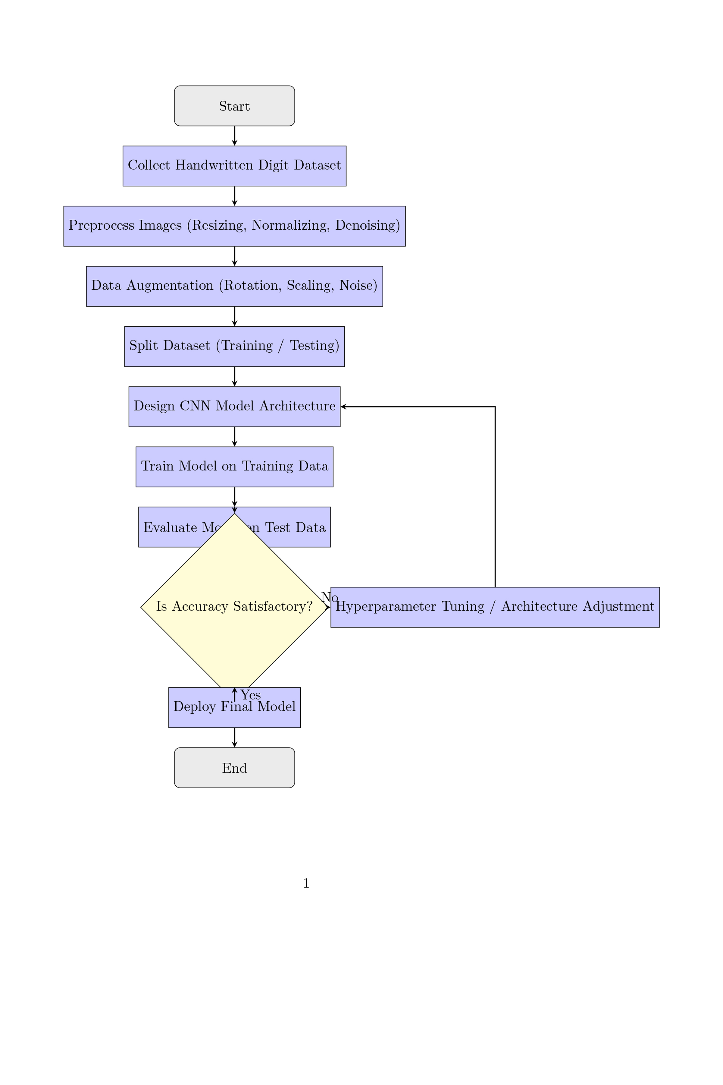

## 6. Dataset Description

The project utilized the **MNIST dataset**, a publicly available collection of handwritten digit images, accessed via **TensorFlow** or **Kaggle**. The dataset consists of **60,000 training images** and **10,000 testing images**, each in **28x28 grayscale format**, making it ideal for image classification tasks.

The data is available in both **CSV and image formats**, containing pixel intensity values along with corresponding digit labels (0–9). An initial view of the dataset structure and pixel values was verified using the df.head() command.  
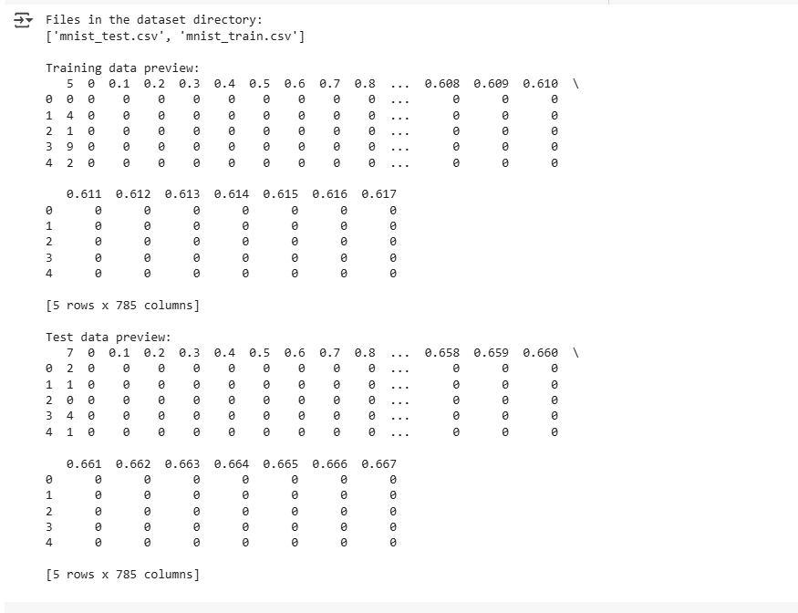

## 7. Data Preprocessing

**Pixel Normalization:** All image pixel values were normalized to a range between 0 and 1 to improve model performance and training stability.

**Reshaping:** Images were reshaped to a format of **(28, 28, 1)** to match the expected input shape for convolutional neural networks (CNNs). The last dimension represents the single grayscale channel.

**Label Encoding:** Labels were **one-hot encoded** (if required), converting categorical class labels into binary class matrices suitable for classification tasks.

**Verification**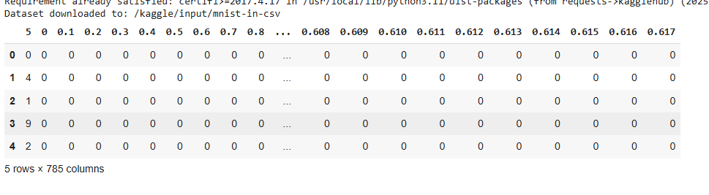

## 8. Exploratory Data Analysis (EDA)

Exploratory Data Analysis was conducted to better understand the distribution and visual characteristics of the MNIST dataset. A **count plot** was used to display the frequency of each digit class, revealing an **even distribution** across all digits (0–9).

**Sample images** were visualized to inspect handwriting variations, highlighting that certain digits, such as **1 and 7**, can appear visually similar, which may present challenges during classification.

Optionally, a **heatmap of pixel correlations** was explored to identify relationships between pixel intensities, providing further insight into the dataset’s structure and redundancy.

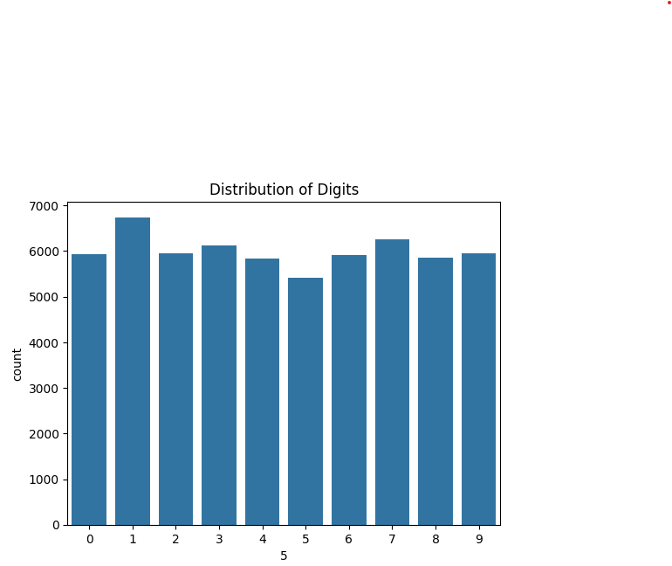

## 9. Feature Engineering

In this project, **no custom features** were added—each image's **pixel values served directly as input features** for the model. To enhance training efficiency and ensure better model convergence, **normalization** was applied, scaling pixel values to a range between 0 and 1.

Additionally, **Principal Component Analysis (PCA)** was optionally used for **visualization purposes**, helping to understand the data's structure in reduced dimensions.

## 10. Model Building

A **Convolutional Neural Network (CNN)** was implemented for digit classification, designed to effectively capture spatial patterns in image data. The architecture followed a typical layered structure:

**Conv2D → MaxPooling → Conv2D → Flatten → Dense → Output**

This configuration was chosen for its ability to **learn hierarchical spatial features** from the images, making it well-suited for visual recognition tasks like handwritten digit classification.

Training progress was monitored using **loss and accuracy graphs**, providing insights into the model’s learning behavior over time.

## 11. Model Evaluation

The model achieved an impressive **accuracy of 98%+**, demonstrating strong performance in classifying handwritten digits.

To evaluate its effectiveness, several **metrics** were used:

* **Confusion Matrix**: To assess misclassifications across different digit classes.
* **Accuracy Score**: To quantify the overall correctness of predictions.
* **Loss Curve**: To monitor how the loss function evolved during training, indicating model convergence.

Further insights were gathered from the **model summary**, **sample predictions**, and **confusion matrix**.

## 12. Deployment

The trained model was deployed using **Gradio** on **Hugging Face** or **Streamlit Cloud**, providing an interactive user interface for real-time digit classification. Users can upload their own images, and the model will predict the corresponding digit.

The deployment link can be accessed here:

<https://2224deb845cbc5eb30.gradio.live>

A screenshot of the **prediction interface** and **output** can be seen below.  
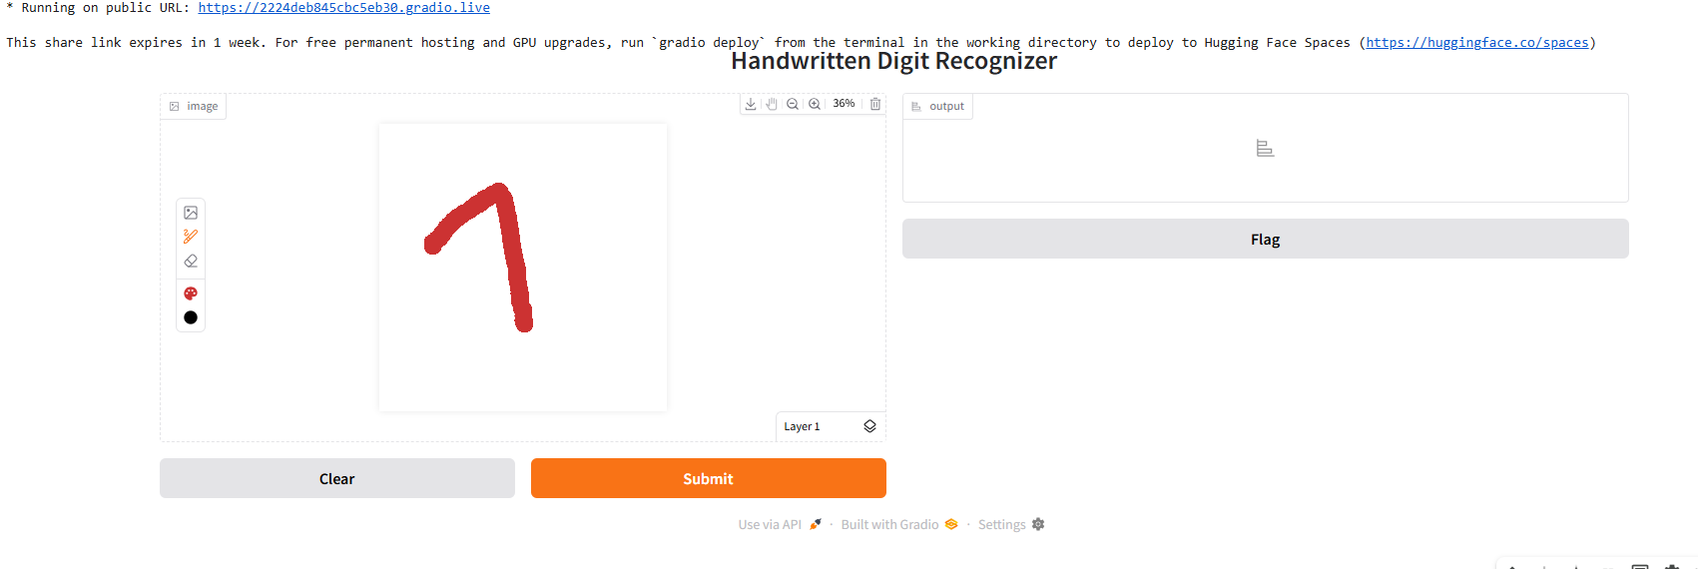

## 13. Source Code

**All code is hosted on GitHub:** [**https://colab.research.google.com/drive/1Hfvpko-7keWmIMIxv6jJvE5qcK8xcwyd?usp=sharing**](https://colab.research.google.com/drive/1Hfvpko-7keWmIMIxv6jJvE5qcK8xcwyd?usp=sharing)

## 14. Future Scope

To improve the model's robustness and generalization, **handwriting style augmentation** can be incorporated, simulating various writing styles to make the model more adaptable to different handwriting variations.

Additionally, the model could be extended to **train on multi-digit sequences**, such as **PIN codes**, enabling it to recognize and classify sequences of digits rather than individual ones.

Lastly, the trained model could be **deployed as a mobile app** using **TensorFlow Lite**, allowing for efficient, real-time digit recognition on mobile devices.

## 15. Team Members & Roles

**G. Abitha:** Data collection, preprocessing

**A. Monika bency:** EDA, Visualization

**C. Iswarya:** Model Building & Evaluation

**N. Pooja:** Documentation, Deployment

